4-4-2 Formation Guide

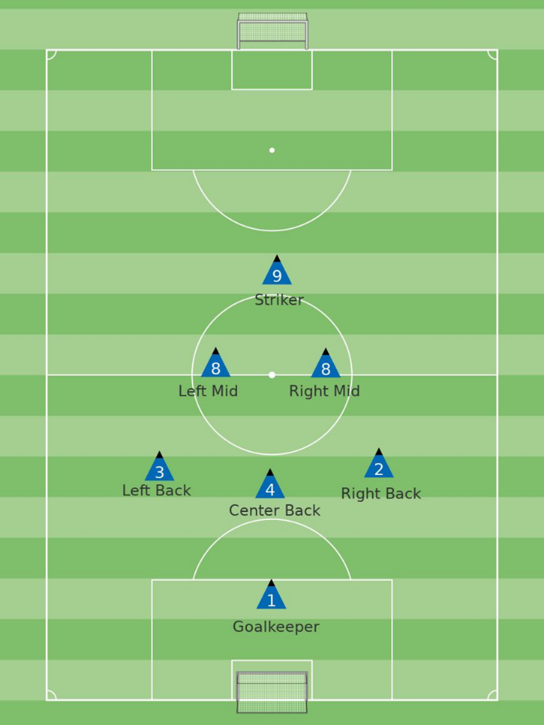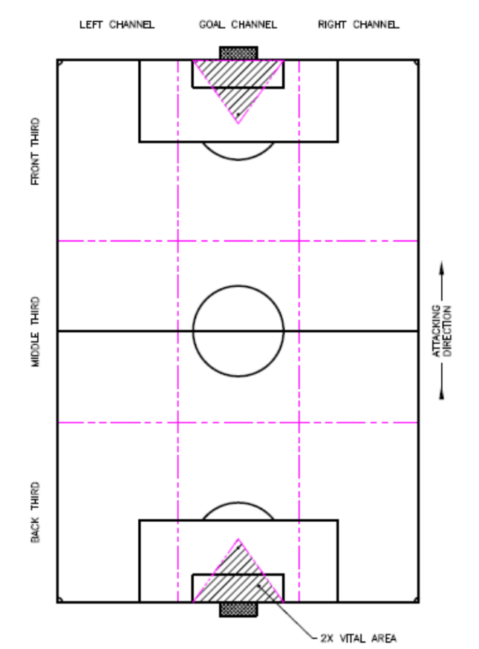

1) Forward (# 9) during the run of play:
On offense:
• Our forward gets high to the opponent’s line of defense (to stretch the field holding their line of defense high so that we have room underneath to work on offense)---take as much space as they will give you; get as high as our opponent’s deepest defender so that you are “on sides”.
• Our forward will crash the nearside goalpost when the ball is wide.
• Our forward checks to the ball; get open to space in order to provide a passing option.
• Stay at least 10 yards away from teammates while working together.
On defense:
• Our forward cuts passing lanes.
• Our forward attacks the ball to become the first defender at our chosen line of confrontation (low, medium, high pressure);
• Close down: quick, slow, sideways, low, shepherd (steer) wide in all parts of the field. Deny the long/penetrating pass.

2) Mids (# 8s) during the run of play:
On offense:
• Our weak-side mid compresses inside to space providing a passing option; check to the ball. Crash the far-side goalpost when the ball is wide.
• Our strong-side mid gets to the line, open, ready to receive a pass, body open to the ball and to goal. Crash the near side goalpost when the ball is wide.
• Work with Forwards, Outside Backs, and Center Back to move, widen, & penetrate the defense.
• Provide overlapping runs with striker (run wide if our striker is inside, run inside if our striker is outside).
On defense:
• Our weak-side mid, if no man up field in your channel, compress inside to a man (mark him, pass him off and then take the next man up field in your area, zonal defending, always shepherd (steer) wide in all parts of the field).
• Our strong-side mid, the play will be near you so either pressure (quick, slow, sideways, low), or cover (second defender), or mark a man near you cutting the passing lane to the man you are marking.
• Recover to mark a man in the goal channel, stay with him and then pass him off to a deeper teammate then sprint up field to take the next man up field in your area; zonal defending; shepherd wide.
• Be the first defender if the first attacker is near you. Don’t just drop into space behind you—step to a man. Do not get even (lateral) with our line of defense. Take a man up field in the goal channel.
• On set pieces, delay the attacking teams kick on fouls & control the area at the top of our box. Provide strong headed & kicked clearances out of the goal channel.

3) Outside backs (# 2 & 3) during the run of play:
On offense:
• All backs push up quickly once possession is won (create offsides) and compress the field (vertical compression) to about 35 yards from the ball.
• Our weak side outside back compresses inside to create the line of defense with the other backs.
• Our strong side outside back attacks up field (play like a forward but get back on transition); Provide overlapping runs with outside mids (run wide if our outside mid is inside, run inside if our wide outside mid is outside---look for space upfield).
On defense:
• All backs drop to create the line of defense.
• Once the line of defense is set, then our weak side back balances and our strong side marks.
• Mark inside, shepherd wide in all parts of the field.

6) Inside back (# 4) during the run of play:
On offense:
• Ensure all backs push up to compress the field (vertical compression) to about 35 yards from the ball.
• After winning the ball, dribble/carry the ball until the opposition closes you. Then pass to penetrate or widen the play.
• On offense or set pieces, if a back goes up field on attack, switch to a two-man defense, and if possession shifts, jockey to delay the attack.
On defense:
• Center back holds the goal channel.
• On defense, step up to become the first defender if the first attacker is near you. An outside back should then get into a cover position behind you (second defender).
• If marking one opponent, stay goal side of him.
• Once our line of defense is set, the center back should be slightly retracted behind our line of defense (to collect long balls over the top or through balls).
• Start to organize our defense as soon as the ball crosses the half way line----organize our mids and our backs loudly, start early!!!!!
7) Keeper (# 1) during the run of play:
On offense:
• Ensure all backs push up to compress the field (vertical compression) to about 20 yards from the ball.
• After winning the ball, run forward to quickly play the ball behind the opposition forwards/midfield with focused ball distribution outside of the goal channel.
• When receiving a backpass, switch the field of play quickly to the opposite back/wing to generate penetration.
On defense:
• Always guard the near post and catch or push saves wide of the goal channel.
• Be decisive on your line: Stay on your line unless there is a ball played in the air inside the 6 yd box or a one-on-one break into the box.
• Start to organize our defense as soon as the ball crosses the half way line----organize our mids and our backs loudly, start early!!!!!

